Overview Questions

1. Which grant fund are you applying to?
Voluntary Youth Organisations Development Fund (Grant)
Voluntary Youth Organisations Development Fund (Bursary)
Community Development Grant Fund (Starter Grant)
Community Development Grant Fund (Existing Groups)
Arts Grants Projects Scheme
Arts Grants Training Grant
Sports Development Grant for Individuals
Sports Development Grant for Groups
Core Funding Grant

2. How much are you requesting? £

3. Please summarise briefly (one or two sentences) what the grant money will be used for

4. Which of the Council’s objectives are you making a contribution to? (tick more than one if appropriate)
Healthy Halton
Halton’s Urban Renewal
Halton’s Children and Young People
Employment, Learning and Skills in Halton
Safer Halton

5. Are you applying as an individual or on behalf of a group or organisation?
Individual
Group

IF GROUP:
(a) What is the name of your group? (please include any names your group has previously been known as):

(b) Which geographical area does your organisation cover?
Runcorn
Widnes
Halton wide
Estate based (if estate based, which estates?)

(c) Has your organisation ever applied to Halton Borough Council for a grant before?

Yes (give details below including to which fund you applied, how much you applied for, briefly what the money was to be used for and whether your application was successful)

No

IF INDIVIDUAL:
(a) What is your name?

(b) Have you ever applied to Halton Borough Council for a grant before?

Yes (give details below including to which fund you applied, how much you applied for, briefly what the money was to be used for and whether your application was successful)

No

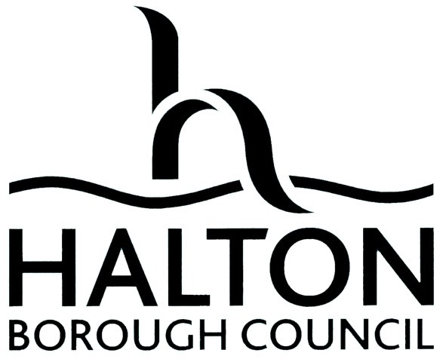

HALTON BOROUGH COUNCIL

SPORTS DEVELOPMENT GRANT

BURSARY APPLICATION FORM
2024 - 2025

Please ensure that you read the “Guide for Applicants” and have spoken to the Councils Sports Development Team before you complete this form

- WHO QUALIFIES FOR A BURSARY GRANT?

You must live in the Borough of Halton and show legitimate need for grant assistance.
There is no limit on age, but preference will be given to those under 21 years of age.

No funding will be automatic as each application will be considered on merit and all funding is at the discretion of the Council.
The Council will generally consider one application per person in each financial year. Any exceptions will be at the discretion of the Council.

- HOW MUCH CAN I APPLY FOR?

There are no set amounts for disbursement and each application will be considered on its merits. A guideline amount for the application is £50 to £150. You can now submit your application on-line by going to www.halton.gov.uk , click on “Halton on-line” and follow the instructions. If you do not have access to the internet, please post your application to GRANTS APPLICATIONS, Halton Borough Council, Halton Stadium, Lowerhouse Lane, Widnes WA8 7DZ
If you will be sending your application by post, please complete the attached overview questions. If you are submitting your application on-line, you will be asked to answer these questions before you submit.
Applications can be made at any time and will be considered and decided upon by the Council’s Executive Board Member responsible for Sport within 28 working days, provided that all supporting evidence is submitted. A copy of the application will be sent to relevant individual as appropriate for comments. Bursary applications will include consideration by a representative of a governing body and may take longer than 28 working days in some circumstances.

- DEFINITIONS

For the purpose of clarity, the following definitions apply;

Career Direction Opportunity
This refers to applications made by individuals who can demonstrate evidence of seeking a career in sports activity.

Personal Sports Development
This refers to applications made by individuals who wish to improve their personal development skills, which in some cases will be distinct from a pursuit of a career in sports activity.

There will be applications were both of the above definitions may apply. Applicants are advised to seek advice from the Sports Development Team if this is the case.

For further information and advice please contact the Sports Development Team on 0151 511 8282

Reference Number
- Personal Details

I need your permission to keep and store this information so I can reply to you regarding your grant application.

Tick the box for YES

Name and Address for correspondence (including full postcode)

Postcode:

Daytime Telephone: Evening Telephone:

Email Address ………………………………………………………………………………………………………………………………

Age Date of Birth:

School/College if applicable

Full time/Part time education if applicable

Job if applicable

Your Sport

Main place of training/coaching

Please list any representative appearances/coaching activities over the last twelve months

School/Club/Centre

County
Regional/National

Best performance last season

Best performance this season

Is this a career opportunity? | Yes |  | No

If yes please state in 50 words or less how this bursary will assist you or others you could assist as a result of this application.

Is this a personal sports development application? | Yes |  | No

If yes please state in 50 words or less how this bursary will assist you or your sport

- What are your goals

A. For this year/season

- For next year/season

4. | Are you currently applying for any other grant aid assistance  or received any in the last 12 months? | Yes |  | No

a. If yes please give details, including telephone number for contact reasons.

- Please give a breakdown of the total cost of the event, training, equipment, trip, tour etc for which you are applying

Total amount requested =

- How much will you raise or contribute yourself

- Please give your details of your
Regional/Governing Body Address (if applicable).

Liaison Officer details (e.g. club coach, regional coach) – this important as the Sports Development Team will need to call your coach to verify your application.

Name and signature of Coach

Coach Signature

Address

Telephone Number

6. Are you related to a councillor or officer of Halton Borough Council? (This includes a blood relative or partner)

Yes |  | No

If yes, please give details (i.e. name of councillor, or if an employee name and department (he/she works within).

(For clarity please discuss this section with the council officer processing this application if you need to complete it)

I need your permission to keep and store your banking information, I will need this information if your grant application is successful so I can make a payment.

Tick the box for YES

7. Tell us your bank account details. You must complete all parts of this question

Account name
Bank / Building society name
Bank / Building society address
 | Sort code |  |  |  |  |  |  |  |  | Account number
 |  |  |  |  |  |  |  |  |  |  |  |  |  | (This must be 8 digits long)
 | Building Society roll number (if applicable)

8. Declaration of Interest

To be signed by the person submitting this application

- I confirm that the monies applied for will be used for the stated purpose within this application and not for any other personal purpose.

- Reports for National or International Visits/Tours

Any recipient of grant for National or International related visits or tours will be required to submit a written report within one month of returning from the event. Advice on this can be obtained from the Council’s Sports Development Team during the application process.

I confirm that my application, if successful, qualifies, as above, and I agree to submit a written report within one month of returning from the visit or tour.

Signed

Print name

DISCLAIMER

The information provided may be used and processed by the Council for other legal purposes and may, in certain circumstances be disclosed to other organisations. The use, processing and disclosure of the information is subject to data protection and related legal controls. Your signature of this document indicates your approval, where required by law, to all proper uses and disclosures by the Council. If you require any further information then please contact the Sports Development Team on 0151 511 8282.

SIGNATURE OF APPLICANT
(PARENT OR GUARDIAN IF UNDER 18)
PRINT NAME |  | DATE

